**Exercise 1: Configuring a Basic Spring Application**

**Code:**

**Pom.xml:**

<project xmlns="http://maven.apache.org/POM/4.0.0"

xmlns:xsi="http://www.w3.org/2001/XMLSchema-instance"

xsi:schemaLocation="http://maven.apache.org/POM/4.0.0

http://maven.apache.org/xsd/maven-4.0.0.xsd">

<modelVersion>4.0.0</modelVersion>

<groupId>com.library</groupId>

<artifactId>LibraryManagement</artifactId>

<version>1.0-SNAPSHOT</version>

<dependencies>

<!-- Spring Core -->

<dependency>

<groupId>org.springframework</groupId>

<artifactId>spring-context</artifactId>

<version>5.3.30</version>

</dependency>

</dependencies>

</project>

**applicationContext.xml:**

<?xml version="1.0" encoding="UTF-8"?>

<beans xmlns="http://www.springframework.org/schema/beans"

xmlns:xsi="http://www.w3.org/2001/XMLSchema-instance"

xsi:schemaLocation="

http://www.springframework.org/schema/beans

http://www.springframework.org/schema/beans/spring-beans.xsd">

<!-- BookRepository Bean -->

<bean id="bookRepository" class="com.library.repository.BookRepository" />

<!-- BookService Bean -->

<bean id="bookService" class="com.library.service.BookService">

<property name="bookRepository" ref="bookRepository"/>

</bean>

</beans>

**BookRepository.java:**

package com.library.repository;

public class BookRepository {

public void saveBook() {

System.out.println("Book saved to repository");

}

}

**BookService.java:**

package com.library.service;

import com.library.repository.BookRepository;

public class BookService {

private BookRepository bookRepository;

public void setBookRepository(BookRepository bookRepository) {

this.bookRepository = bookRepository;

}

public void addBook() {

System.out.println("BookService: Adding book...");

bookRepository.saveBook();

}

}

**Main Class:**

**LibraryManagementApplication.java:**

package com.library.main;

import com.library.service.BookService;

import org.springframework.context.ApplicationContext;

import org.springframework.context.support.ClassPathXmlApplicationContext;

public class LibraryManagementApplication {

public static void main(String[] args) {

ApplicationContext context =

new ClassPathXmlApplicationContext("applicationContext.xml");

BookService bookService = context.getBean("bookService", BookService.class);

bookService.addBook();

}

}

**Output:**

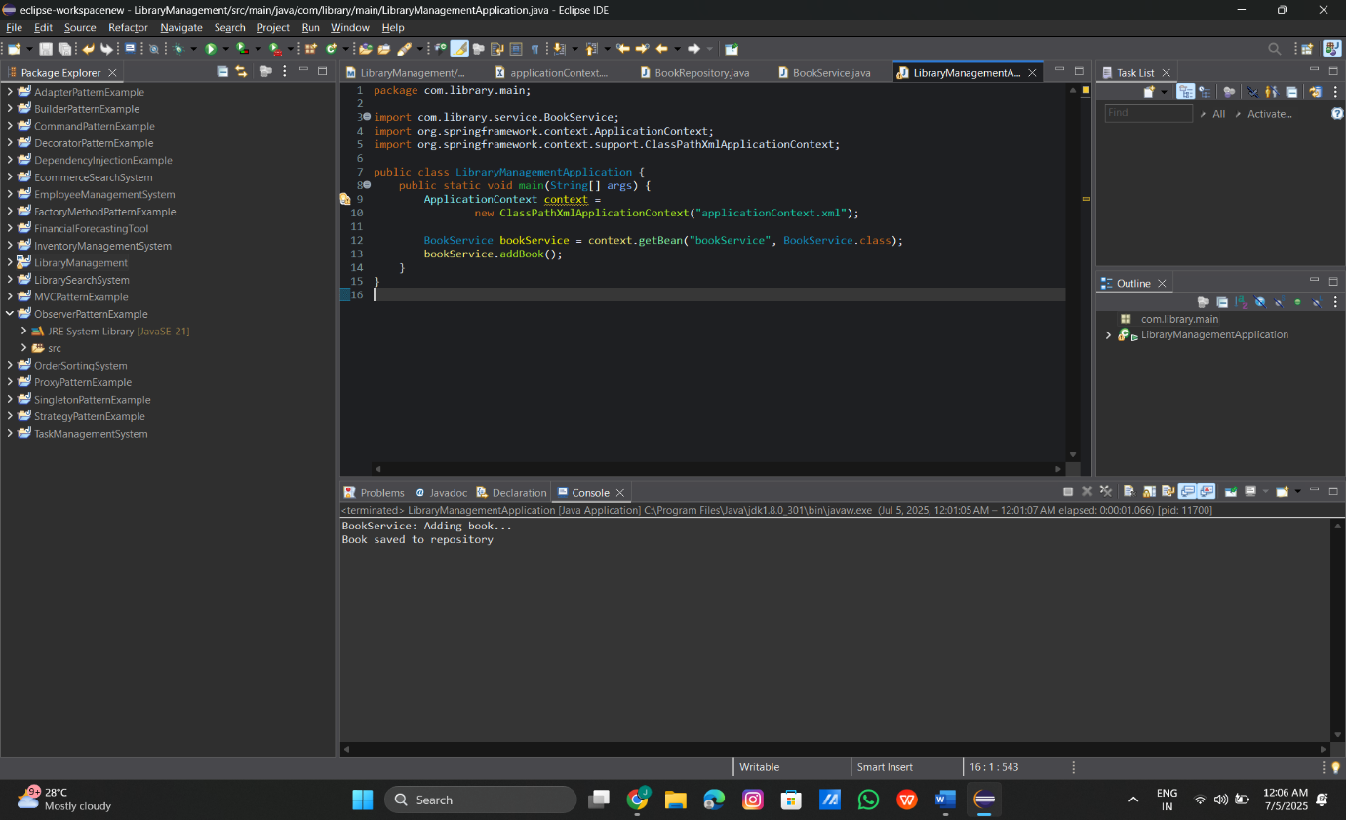

**Exercise 2: Implementing Dependency Injection**

**Code:**

**Pom.xml:**

<project xmlns="http://maven.apache.org/POM/4.0.0"

xmlns:xsi="http://www.w3.org/2001/XMLSchema-instance"

xsi:schemaLocation="http://maven.apache.org/POM/4.0.0

http://maven.apache.org/xsd/maven-4.0.0.xsd">

<modelVersion>4.0.0</modelVersion>

<groupId>com.library.di</groupId>

<artifactId>LibraryDIProject</artifactId>

<version>1.0-SNAPSHOT</version>

<dependencies>

<!-- Spring Core -->

<dependency>

<groupId>org.springframework</groupId>

<artifactId>spring-context</artifactId>

<version>5.3.30</version>

</dependency>

</dependencies>

</project>

**BookRepository.java:**

package com.library.repository;

public class BookRepository {

public void saveBook() {

System.***out***.println("BookRepository: Saving book to the database...");

}

}

**BookService.java:**

package com.library.service;

import com.library.repository.BookRepository;

public class BookService {

private BookRepository bookRepository;

public void setBookRepository(BookRepository bookRepository) {

this.bookRepository = bookRepository;

}

public void performSave() {

System.***out***.println("BookService: Preparing to save book...");

bookRepository.saveBook();

}

}

**applicationContext.xml:**

<?xml version="1.0" encoding="UTF-8"?>

<beans xmlns="http://www.springframework.org/schema/beans"

xmlns:xsi="http://www.w3.org/2001/XMLSchema-instance"

xsi:schemaLocation="

http://www.springframework.org/schema/beans

http://www.springframework.org/schema/beans/spring-beans.xsd">

<!-- Bean for BookRepository -->

<bean id="bookRepository" class="com.library.repository.BookRepository"/>

<!-- Bean for BookService with setter injection -->

<bean id="bookService" class="com.library.service.BookService">

<property name="bookRepository" ref="bookRepository"/>

</bean>

</beans>

**LibraryDIApplication.java:**

package com.library.main;

import com.library.service.BookService;

import org.springframework.context.ApplicationContext;

import org.springframework.context.support.ClassPathXmlApplicationContext;

public class LibraryDIApplication {

public static void main(String[] args) {

ApplicationContext context =

new ClassPathXmlApplicationContext("applicationContext.xml");

BookService service = context.getBean("bookService", BookService.class);

service.performSave();

}

}

**Output:**

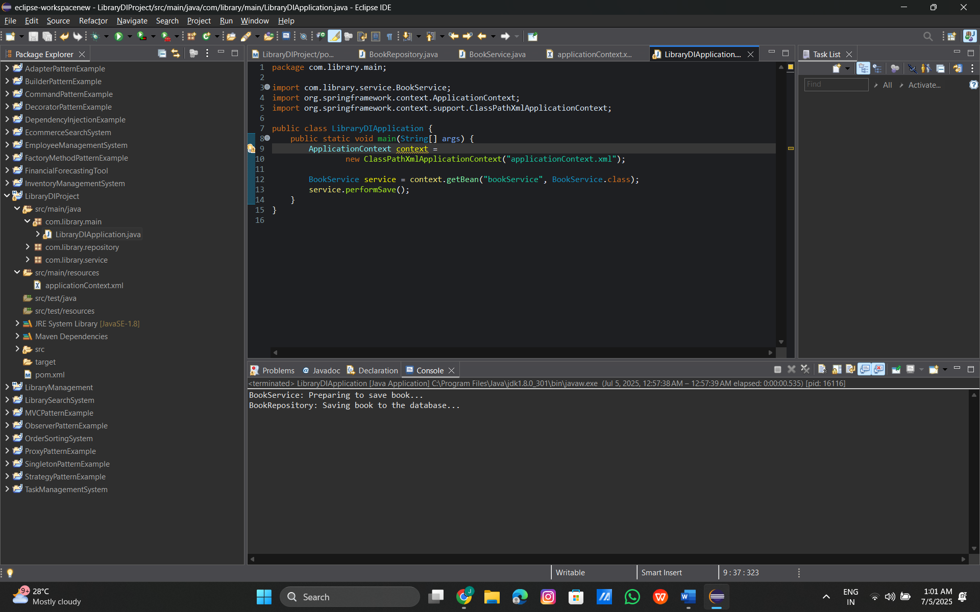

**Exercise 3: Implementing Logging with Spring AOP**

**Code:**

**pom.xml:**

<project xmlns="http://maven.apache.org/POM/4.0.0"

xmlns:xsi="http://www.w3.org/2001/XMLSchema-instance"

xsi:schemaLocation="http://maven.apache.org/POM/4.0.0

http://maven.apache.org/xsd/maven-4.0.0.xsd">

<modelVersion>4.0.0</modelVersion>

<groupId>com.library.aop</groupId>

<artifactId>LibraryAOPProject</artifactId>

<version>1.0-SNAPSHOT</version>

<dependencies>

<!-- Spring Context -->

<dependency>

<groupId>org.springframework</groupId>

<artifactId>spring-context</artifactId>

<version>5.3.30</version>

</dependency>

<!-- Spring AOP -->

<dependency>

<groupId>org.springframework</groupId>

<artifactId>spring-aspects</artifactId>

<version>5.3.30</version>

</dependency>

</dependencies>

</project>

**BookService.java:**

package com.library.service;

public class BookService {

public void issueBook() {

System.out.println("BookService: Issuing book to member...");

}

}

**LoggingAspect.java:**

package com.library.aspect;

import org.aspectj.lang.ProceedingJoinPoint;

public class LoggingAspect {

public Object logExecutionTime(ProceedingJoinPoint joinPoint) throws Throwable {

long start = System.currentTimeMillis();

Object result = joinPoint.proceed();

long end = System.currentTimeMillis();

System.out.println("Execution time of " + joinPoint.getSignature() + " = " + (end - start) + " ms");

return result;

}

}

**applicationContext.xml:**

<?xml version="1.0" encoding="UTF-8"?>

<beans xmlns="http://www.springframework.org/schema/beans"

xmlns:xsi="http://www.w3.org/2001/XMLSchema-instance"

xmlns:aop="http://www.springframework.org/schema/aop"

xsi:schemaLocation="

http://www.springframework.org/schema/beans http://www.springframework.org/schema/beans/spring-beans.xsd

http://www.springframework.org/schema/aop http://www.springframework.org/schema/aop/spring-aop.xsd">

<!-- Enable AOP support -->

<aop:aspectj-autoproxy />

<!-- Service Bean -->

<bean id="bookService" class="com.library.service.BookService" />

<!-- Logging Aspect Bean -->

<bean id="loggingAspect" class="com.library.aspect.LoggingAspect" />

<!-- AOP Configuration -->

<aop:config>

<aop:aspect ref="loggingAspect">

<aop:around method="logExecutionTime"

pointcut="execution(* com.library.service.*.*(..))"/>

</aop:aspect>

</aop:config>

</beans>

**LibraryAOPApplication.java:**

package com.library.main;

import com.library.service.BookService;

import org.springframework.context.ApplicationContext;

import org.springframework.context.support.ClassPathXmlApplicationContext;

public class LibraryAOPApplication {

public static void main(String[] args) {

ApplicationContext context = new ClassPathXmlApplicationContext("applicationContext.xml");

BookService service = context.getBean("bookService", BookService.class);

service.issueBook();

}

}

**Output:**

**Exercise 4: Creating and Configuring a Maven Project**

**Code:**

**pom.xml:**

<project xmlns="http://maven.apache.org/POM/4.0.0"

xmlns:xsi="http://www.w3.org/2001/XMLSchema-instance"

xsi:schemaLocation="http://maven.apache.org/POM/4.0.0

http://maven.apache.org/xsd/maven-4.0.0.xsd">

<modelVersion>4.0.0</modelVersion>

<groupId>com.library.project</groupId>

<artifactId>LibrarySpringWeb</artifactId>

<version>1.0-SNAPSHOT</version>

<dependencies>

<!-- Spring Context -->

<dependency>

<groupId>org.springframework</groupId>

<artifactId>spring-context</artifactId>

<version>5.3.30</version>

</dependency>

<!-- Spring AOP -->

<dependency>

<groupId>org.springframework</groupId>

<artifactId>spring-aspects</artifactId>

<version>5.3.30</version>

</dependency>

<!-- Spring Web MVC -->

<dependency>

<groupId>org.springframework</groupId>

<artifactId>spring-webmvc</artifactId>

<version>5.3.30</version>

</dependency>

</dependencies>

<!-- Maven Compiler Plugin -->

<build>

<plugins>

<plugin>

<artifactId>maven-compiler-plugin</artifactId>

<version>3.8.1</version>

<configuration>

<source>1.8</source>

<target>1.8</target>

</configuration>

</plugin>

</plugins>

</build>

</project>

**Output:**

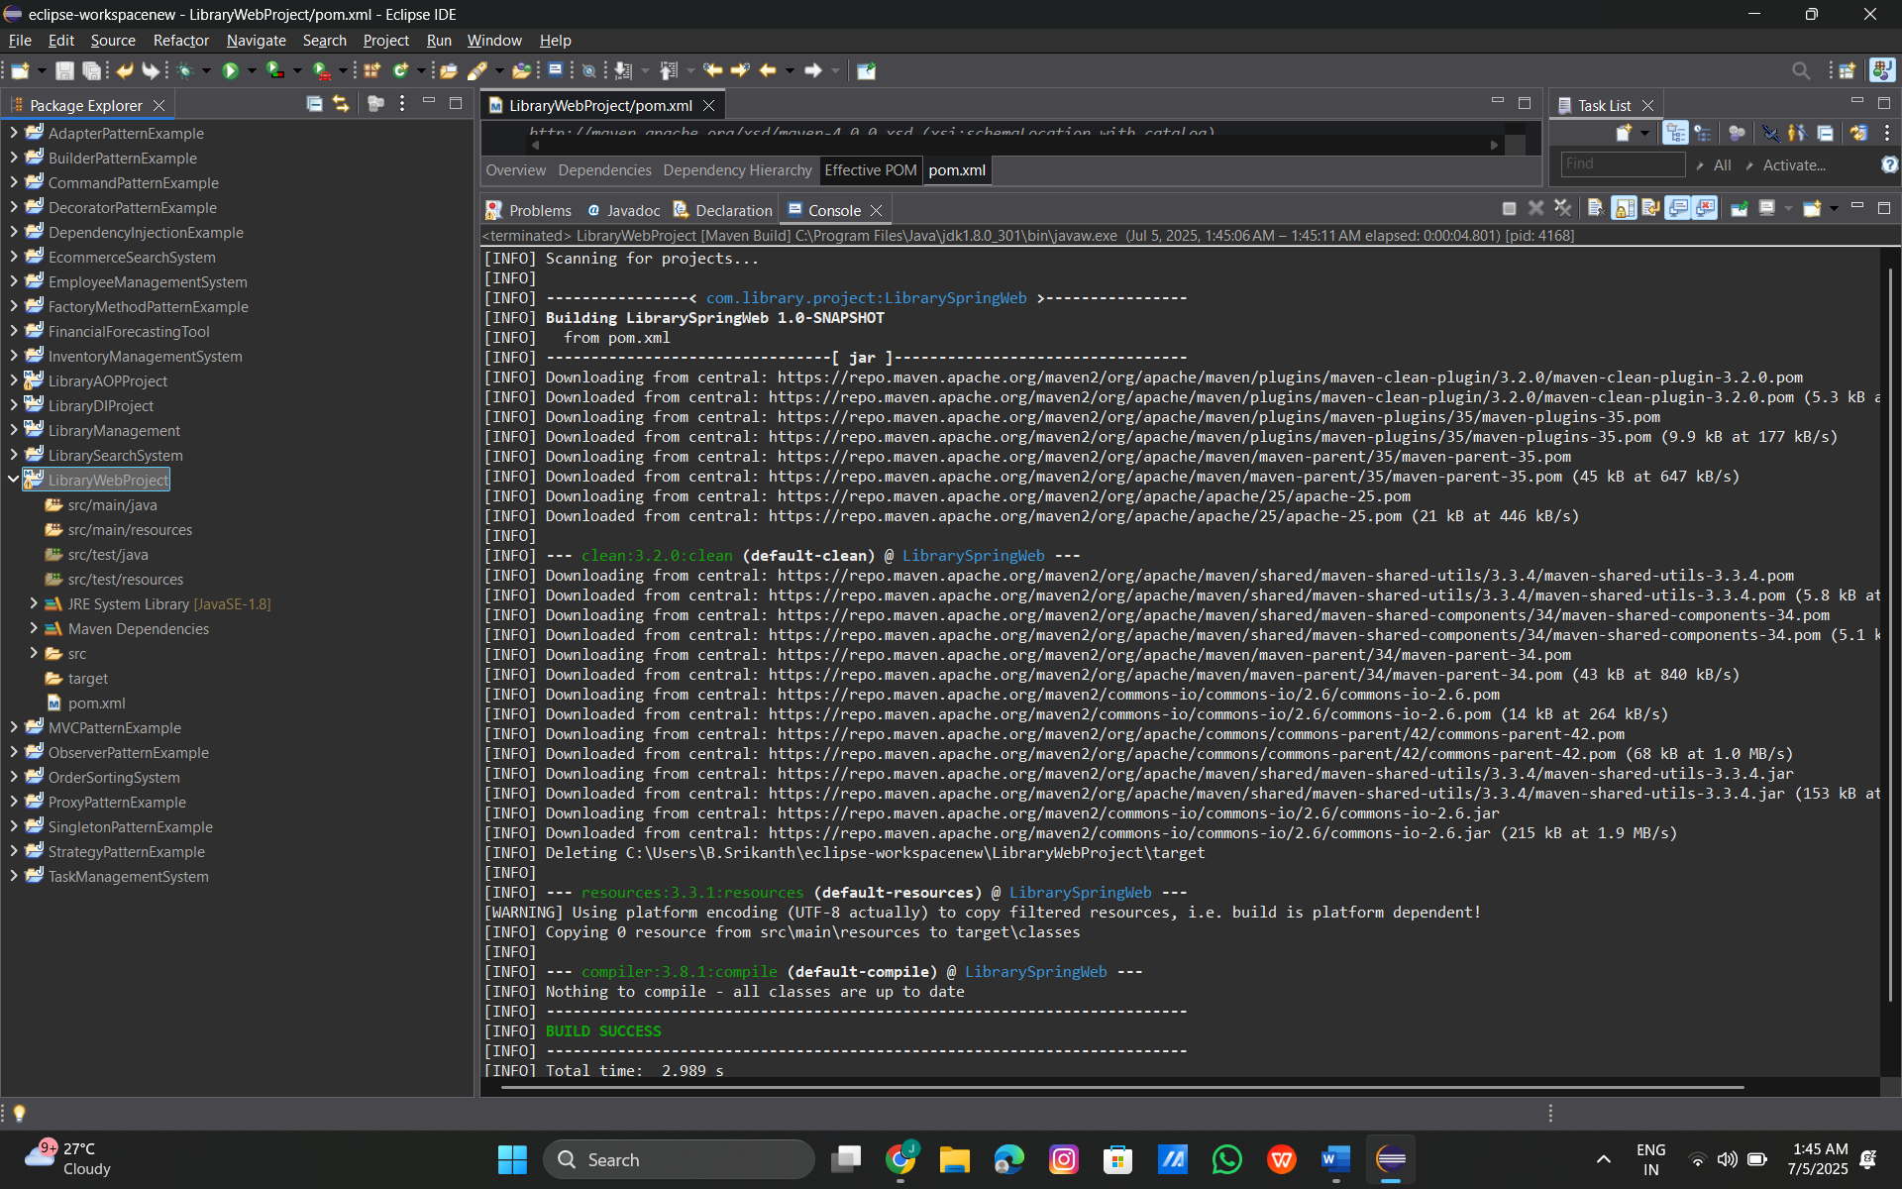

**Exercise 5: Configuring the Spring IoC Container**

**Code:**

**Pom.xml:**

<project xmlns="http://maven.apache.org/POM/4.0.0"

xmlns:xsi="http://www.w3.org/2001/XMLSchema-instance"

xsi:schemaLocation="http://maven.apache.org/POM/4.0.0

http://maven.apache.org/xsd/maven-4.0.0.xsd">

<modelVersion>4.0.0</modelVersion>

<groupId>com.library.ioc</groupId>

<artifactId>LibraryIoCProject</artifactId>

<version>1.0-SNAPSHOT</version>

<dependencies>

<!-- Spring Core Context -->

<dependency>

<groupId>org.springframework</groupId>

<artifactId>spring-context</artifactId>

<version>5.3.30</version>

</dependency>

</dependencies>

<build>

<plugins>

<!-- Java 1.8 Compiler Plugin -->

<plugin>

<groupId>org.apache.maven.plugins</groupId>

<artifactId>maven-compiler-plugin</artifactId>

<version>3.8.1</version>

<configuration>

<source>1.8</source>

<target>1.8</target>

</configuration>

</plugin>

</plugins>

</build>

</project>

**BookRepository.java:**

package com.library.repository;

public class BookRepository {

public void save() {

System.out.println("BookRepository: Book saved successfully!");

}

}

**BookService.java:**

package com.library.service;

import com.library.repository.BookRepository;

public class BookService {

private BookRepository bookRepository;

public void setBookRepository(BookRepository bookRepository) {

this.bookRepository = bookRepository;

}

public void saveBook() {

System.out.println("BookService: Delegating save operation...");

bookRepository.save();

}

}

**applicationContext.xml:**

<?xml version="1.0" encoding="UTF-8"?>

<beans xmlns="http://www.springframework.org/schema/beans"

xmlns:xsi="http://www.w3.org/2001/XMLSchema-instance"

xsi:schemaLocation="

http://www.springframework.org/schema/beans

http://www.springframework.org/schema/beans/spring-beans.xsd">

<!-- Repository Bean -->

<bean id="bookRepository" class="com.library.repository.BookRepository"/>

<!-- Service Bean with Setter Injection -->

<bean id="bookService" class="com.library.service.BookService">

<property name="bookRepository" ref="bookRepository"/>

</bean>

</beans>

**LibraryIoCApplication.java:**

package com.library.main;

import com.library.service.BookService;

import org.springframework.context.ApplicationContext;

import org.springframework.context.support.ClassPathXmlApplicationContext;

public class LibraryIoCApplication {

public static void main(String[] args) {

ApplicationContext context =

new ClassPathXmlApplicationContext("applicationContext.xml");

BookService bookService = context.getBean("bookService", BookService.class);

bookService.saveBook();

}

}

**Output:**

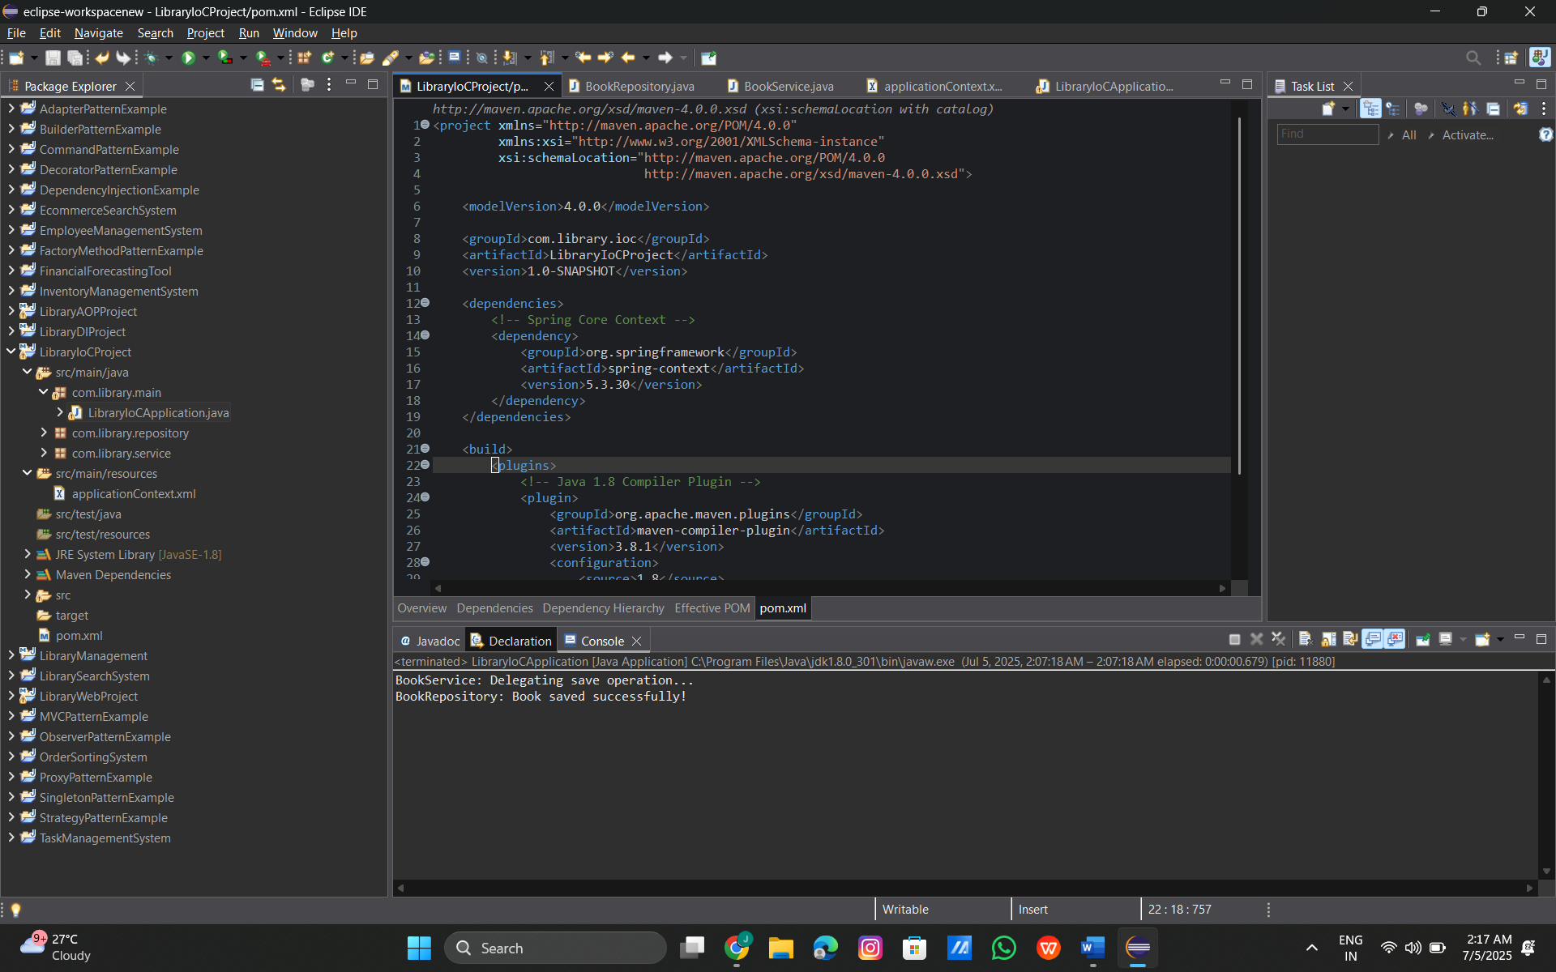

**Exercise 6: Configuring Beans with Annotations**

**Code:**

**pom.xml:**

<project xmlns="http://maven.apache.org/POM/4.0.0"

xmlns:xsi="http://www.w3.org/2001/XMLSchema-instance"

xsi:schemaLocation="http://maven.apache.org/POM/4.0.0

http://maven.apache.org/xsd/maven-4.0.0.xsd">

<modelVersion>4.0.0</modelVersion>

<groupId>com.library.annotation</groupId>

<artifactId>LibraryAnnotationProject</artifactId>

<version>1.0-SNAPSHOT</version>

<dependencies>

<!-- Spring Context -->

<dependency>

<groupId>org.springframework</groupId>

<artifactId>spring-context</artifactId>

<version>5.3.30</version>

</dependency>

</dependencies>

<build>

<plugins>

<plugin>

<groupId>org.apache.maven.plugins</groupId>

<artifactId>maven-compiler-plugin</artifactId>

<version>3.8.1</version>

<configuration>

<source>1.8</source>

<target>1.8</target>

</configuration>

</plugin>

</plugins>

</build>

</project>

**BookRepository.java:**

package com.library.repository;

import org.springframework.stereotype.Repository;

@Repository

public class BookRepository {

public void save() {

System.out.println("BookRepository: Book saved with annotation config.");

}

}

**BookService.java:**

package com.library.service;

import com.library.repository.BookRepository;

import org.springframework.beans.factory.annotation.Autowired;

import org.springframework.stereotype.Service;

public class BookService {

@Autowired

private BookRepository bookRepository;

public void addBook() {

System.out.println("BookService: Adding book using annotation config.");

bookRepository.save();

}

}

**applicationContext.xml:**

<?xml version="1.0" encoding="UTF-8"?>

<beans xmlns="http://www.springframework.org/schema/beans"

xmlns:xsi="http://www.w3.org/2001/XMLSchema-instance"

xmlns:context="http://www.springframework.org/schema/context"

xsi:schemaLocation="

http://www.springframework.org/schema/beans

http://www.springframework.org/schema/beans/spring-beans.xsd

http://www.springframework.org/schema/context

http://www.springframework.org/schema/context/spring-context.xsd">

<!-- Enable component scanning -->

<context:component-scan base-package="com.library" />

</beans>

**LibraryAnnotationApplication.java:**

package com.library.main;

import com.library.service.BookService;

import org.springframework.context.ApplicationContext;

import org.springframework.context.support.ClassPathXmlApplicationContext;

public class LibraryAnnotationApplication {

public static void main(String[] args) {

ApplicationContext context =

new ClassPathXmlApplicationContext("applicationContext.xml");

BookService service = context.getBean(BookService.class);

service.addBook();

}

}

**Output:**

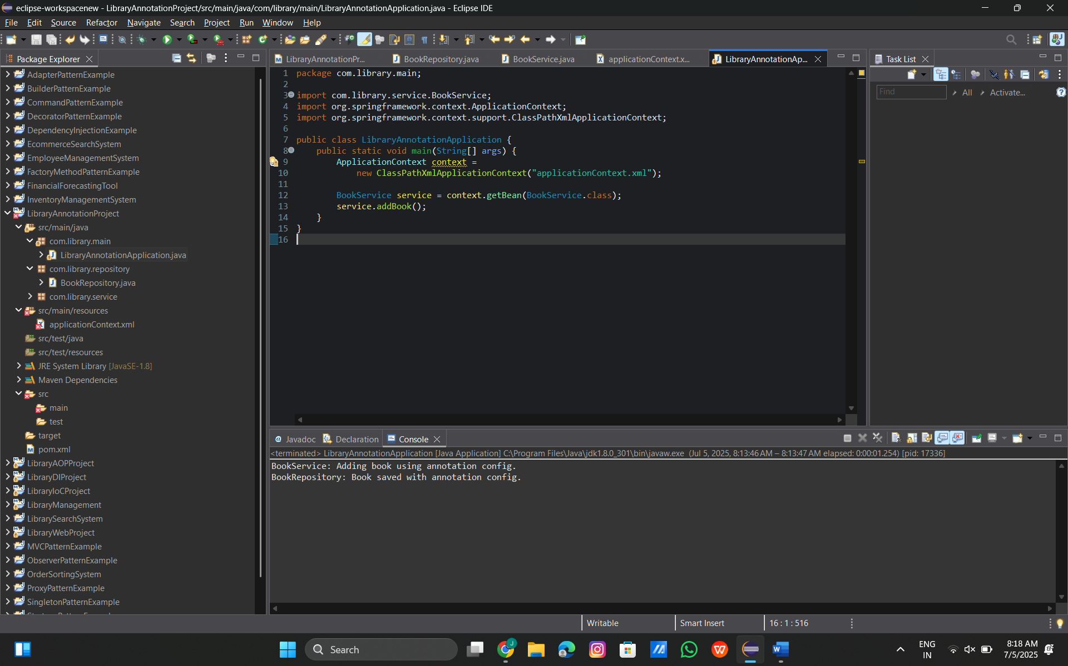

**Exercise 7: Implementing Constructor and Setter Injection**

**Code:**

**pom.xml:**

<project xmlns="http://maven.apache.org/POM/4.0.0"

xmlns:xsi="http://www.w3.org/2001/XMLSchema-instance"

xsi:schemaLocation="http://maven.apache.org/POM/4.0.0

http://maven.apache.org/xsd/maven-4.0.0.xsd">

<modelVersion>4.0.0</modelVersion>

<groupId>com.library.inject</groupId>

<artifactId>LibraryInjectionProject</artifactId>

<version>1.0-SNAPSHOT</version>

<dependencies>

<!-- Spring Context -->

<dependency>

<groupId>org.springframework</groupId>

<artifactId>spring-context</artifactId>

<version>5.3.30</version>

</dependency>

</dependencies>

<build>

<plugins>

<plugin>

<groupId>org.apache.maven.plugins</groupId>

<artifactId>maven-compiler-plugin</artifactId>

<version>3.8.1</version>

<configuration>

<source>1.8</source>

<target>1.8</target>

</configuration>

</plugin>

</plugins>

</build>

</project>

**BookRepository.java:**

package com.library.repository;

public class BookRepository {

public void save() {

System.out.println("BookRepository: Book saved to database.");

}

}

**BookService.java:**

package com.library.service;

import com.library.repository.BookRepository;

public class BookService {

private BookRepository bookRepository;

private String libraryName;

// Constructor injection

public BookService(String libraryName) {

this.libraryName = libraryName;

}

// Setter injection

public void setBookRepository(BookRepository bookRepository) {

this.bookRepository = bookRepository;

}

public void process() {

System.out.println("Library: " + libraryName);

bookRepository.save();

}

}

**applicationContext.xml:**

<?xml version="1.0" encoding="UTF-8"?>

<beans xmlns="http://www.springframework.org/schema/beans"

xmlns:xsi="http://www.w3.org/2001/XMLSchema-instance"

xsi:schemaLocation="http://www.springframework.org/schema/beans

http://www.springframework.org/schema/beans/spring-beans.xsd">

<!-- Bean for BookRepository -->

<bean id="bookRepository" class="com.library.repository.BookRepository"/>

<!-- BookService with constructor and setter injection -->

<bean id="bookService" class="com.library.service.BookService">

<!-- Constructor injection for libraryName -->

<constructor-arg value="City Central Library"/>

<!-- Setter injection for BookRepository -->

<property name="bookRepository" ref="bookRepository"/>

</bean>

</beans>

**LibraryInjectionApplication.java:**

package com.library.main;

import com.library.service.BookService;

import org.springframework.context.ApplicationContext;

import org.springframework.context.support.ClassPathXmlApplicationContext;

public class LibraryInjectionApplication {

public static void main(String[] args) {

ApplicationContext context =

new ClassPathXmlApplicationContext("applicationContext.xml");

BookService service = context.getBean("bookService", BookService.class);

service.process();

}

}

**Output:**

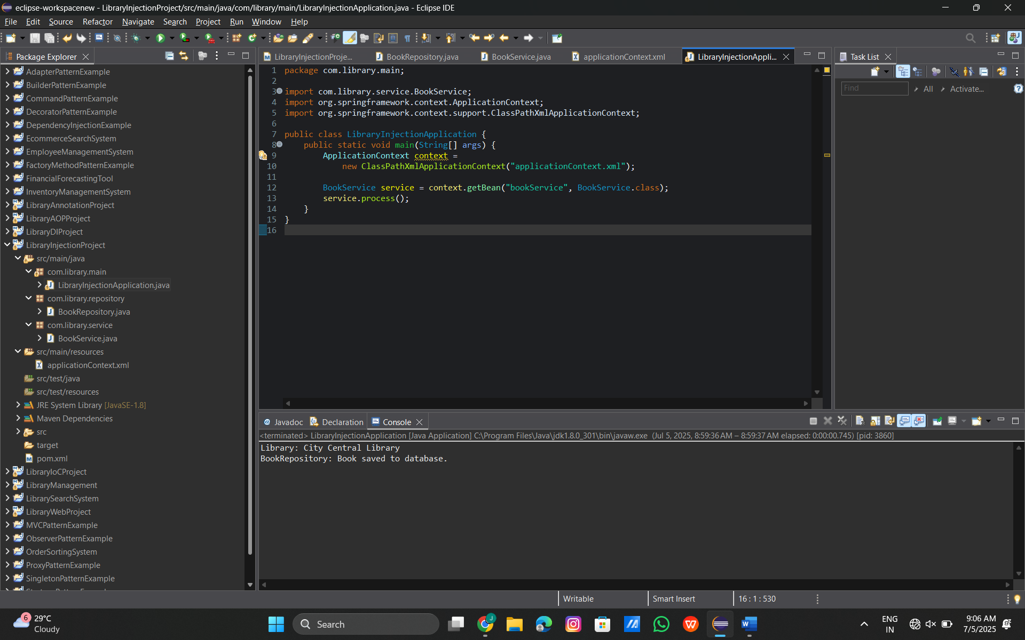

**Exercise 8: Implementing Basic AOP with Spring**

**Code:**

**pom.xml:**

<project xmlns="http://maven.apache.org/POM/4.0.0"

xmlns:xsi="http://www.w3.org/2001/XMLSchema-instance"

xsi:schemaLocation="http://maven.apache.org/POM/4.0.0

http://maven.apache.org/xsd/maven-4.0.0.xsd">

<modelVersion>4.0.0</modelVersion>

<groupId>com.library.aopbasic</groupId>

<artifactId>LibraryAOPBasicProject</artifactId>

<version>1.0-SNAPSHOT</version>

<dependencies>

<!-- Spring Context -->

<dependency>

<groupId>org.springframework</groupId>

<artifactId>spring-context</artifactId>

<version>5.3.30</version>

</dependency>

<!-- Spring AOP -->

<dependency>

<groupId>org.springframework</groupId>

<artifactId>spring-aspects</artifactId>

<version>5.3.30</version>

</dependency>

</dependencies>

<build>

<plugins>

<plugin>

<groupId>org.apache.maven.plugins</groupId>

<artifactId>maven-compiler-plugin</artifactId>

<version>3.8.1</version>

<configuration>

<source>1.8</source>

<target>1.8</target>

</configuration>

</plugin>

</plugins>

</build>

</project>

**BookService.java:**

package com.library.service;

public class BookService {

public void borrowBook() {

System.out.println("BookService: Borrowing a book...");

}

}

**LoggingAspect.java:**

package com.library.aspect;

import org.aspectj.lang.JoinPoint;

public class LoggingAspect {

public void logBefore(JoinPoint joinPoint) {

System.out.println("LoggingAspect: Before method - " + joinPoint.getSignature().getName());

}

public void logAfter(JoinPoint joinPoint) {

System.out.println("LoggingAspect: After method - " + joinPoint.getSignature().getName());

}

}

**applicationContext.xml:**

<?xml version="1.0" encoding="UTF-8"?>

<beans xmlns="http://www.springframework.org/schema/beans"

xmlns:xsi="http://www.w3.org/2001/XMLSchema-instance"

xmlns:aop="http://www.springframework.org/schema/aop"

xsi:schemaLocation="

http://www.springframework.org/schema/beans

http://www.springframework.org/schema/beans/spring-beans.xsd

http://www.springframework.org/schema/aop

http://www.springframework.org/schema/aop/spring-aop.xsd">

<!-- Enable AOP support -->

<aop:aspectj-autoproxy/>

<!-- BookService bean -->

<bean id="bookService" class="com.library.service.BookService"/>

<!-- LoggingAspect bean -->

<bean id="loggingAspect" class="com.library.aspect.LoggingAspect"/>

<!-- AOP Configuration -->

<aop:config>

<aop:aspect ref="loggingAspect">

<aop:pointcut id="bookMethods" expression="execution(* com.library.service.*.*(..))"/>

<aop:before pointcut-ref="bookMethods" method="logBefore"/>

<aop:after pointcut-ref="bookMethods" method="logAfter"/>

</aop:aspect>

</aop:config>

</beans>

**LibraryAOPBasicApplication.java:**

package com.library.main;

import com.library.service.BookService;

import org.springframework.context.ApplicationContext;

import org.springframework.context.support.ClassPathXmlApplicationContext;

public class LibraryAOPBasicApplication {

public static void main(String[] args) {

ApplicationContext context =

new ClassPathXmlApplicationContext("applicationContext.xml");

BookService bookService = context.getBean("bookService", BookService.class);

bookService.borrowBook();

}

}

**Output:**

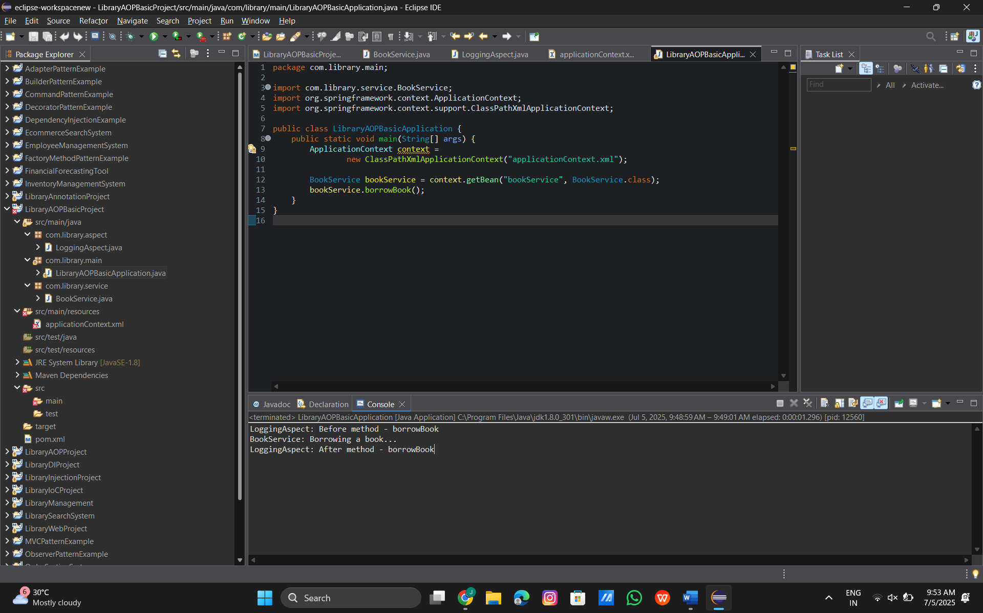

**Exercise 9: Creating a Spring Boot Application**

**Code:**

**pom.xml:**

<project xmlns="http://maven.apache.org/POM/4.0.0"

xmlns:xsi="http://www.w3.org/2001/XMLSchema-instance"

xsi:schemaLocation="http://maven.apache.org/POM/4.0.0 http://maven.apache.org/xsd/maven-4.0.0.xsd">

<modelVersion>4.0.0</modelVersion>

<groupId>com.library</groupId>

<artifactId>LibraryManagement</artifactId>

<version>1.0-SNAPSHOT</version>

<dependencies>

<dependency>

<groupId>org.springframework</groupId>

<artifactId>spring-context</artifactId>

<version>5.3.29</version>

</dependency>

<dependency>

<groupId>org.springframework</groupId>

<artifactId>spring-aop</artifactId>

<version>5.3.29</version>

</dependency>

<dependency>

<groupId>org.aspectj</groupId>

<artifactId>aspectjweaver</artifactId>

<version>1.9.19</version>

</dependency>

</dependencies>

</project>

**LoggingAspect.java:**

package com.library.aspect;

import org.aspectj.lang.annotation.After;

import org.aspectj.lang.annotation.Aspect;

import org.aspectj.lang.annotation.Before;

public class LoggingAspect {

*@Before*("execution(* com.library.service.BookService.*(..))")

public void beforeMethod() {

System.***out***.println("Before method execution (LoggingAspect)");

}

*@After*("execution(* com.library.service.BookService.*(..))")

public void afterMethod() {

System.***out***.println("After method execution (LoggingAspect)");

}

}

**BookService.java:**

package com.library.service;

public class BookService {

public void displayBookInfo() {

System.***out***.println("Displaying book information...");

}

}

**applicationContext.xml:**

<?xml version="1.0" encoding="UTF-8"?>

<beans xmlns="http://www.springframework.org/schema/beans"

xmlns:aop="http://www.springframework.org/schema/aop"

xmlns:context="http://www.springframework.org/schema/context"

xmlns:xsi="http://www.w3.org/2001/XMLSchema-instance"

xsi:schemaLocation="http://www.springframework.org/schema/beans

http://www.springframework.org/schema/beans/spring-beans.xsd

http://www.springframework.org/schema/context

http://www.springframework.org/schema/context/spring-context.xsd

http://www.springframework.org/schema/aop

http://www.springframework.org/schema/aop/spring-aop.xsd">

<context:component-scan base-package="com.library" />

<aop:aspectj-autoproxy />

<bean id="bookService" class="com.library.service.BookService" />

<bean id="loggingAspect" class="com.library.aspect.LoggingAspect" />

</beans>

**LibraryManagementApplication.java:**

package com.library;

import org.springframework.context.ApplicationContext;

import org.springframework.context.support.ClassPathXmlApplicationContext;

import com.library.service.BookService;

public class LibraryManagementApplication {

public static void main(String[] args) {

ApplicationContext context = new ClassPathXmlApplicationContext("applicationContext.xml");

BookService bookService = (BookService) context.getBean("bookService");

bookService.displayBookInfo();

}

}

**Output:**

